Cheatsheet – terms and concepts

Machine Learning – Prediction, Not Inference
High level: Machine learning is about making predictions. Given what we know, what do we expect to happen?
More precise: We're modeling the relationship between input variables X and an output Y. The goal is not to understand why something happens, but to predict what will happen. Given values of X, what do we expect Y to be?
Note: ML can also be applied to time series data for forecasting, but we won't go there today.

The Task – Sales Prediction
High level: We have a bunch of information about sales situations. Can we use that to predict future sales?
More precise: Y is sales. X is everything else, our features. With the information in X, can we build a model that predicts Y accurately?
A take home exercise for you: how could you apply this kind of model in your own field, your own industry, or on a completely different dataset?"

Train/Test Split
We split the data into a training set and a test set. The model learns patterns from the training data. Then we evaluate it on the test set to see how well it generalizes to new, unseen data. This is how we avoid fooling ourselves.

XGBoost – Why Use It?

Three reasons to use XGBoost:
- It handles messy, tabular data well, missing values, mixed types, non-linear relationships
- It's fast and scalable, works well on large datasets
- It consistently performs well in practice, it's a go-to method in competitions and industry for a reason
Three reasons NOT to use it:
- If you need interpretability and explainability, a linear model is easier to communicate and defend
- If your dataset is very small, simpler models may generalize better and are less likely to overfit
- If your data is image, audio, or sequential text, other architectures (CNNs, RNNs, transformers) are better suited

Regression and XGBoost – What's the Connection?
High level: Both regression and XGBoost try to model the relationship between X and Y. The difference is in how.
More precise: Classical regression (linear, logistic) assumes a specific functional form and optimizes it. It's great for inference, understanding coefficients, statistical significance, causality. XGBoost makes no such assumptions. It's flexible and powerful for prediction, but you lose the clean interpretability. Neither is better in general. They answer different questions.

Core Concepts XGBoost
Decision Tree
High level: A tree that asks yes/no questions about the data to arrive at a prediction. Simple and intuitive.
More precise: A decision tree splits the feature space recursively based on thresholds that minimize prediction error. Each leaf node holds a predicted value.

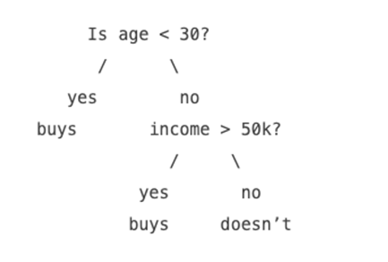
Boosting
High level: Instead of building one big model, we build many small, weak models in sequence. Each one tries to fix the mistakes of the previous one.
More precise: Boosting is an ensemble method where models are trained iteratively. Each new model focuses on the residual errors of the combined previous models. XGBoost is an optimized implementation of gradient boosted trees.

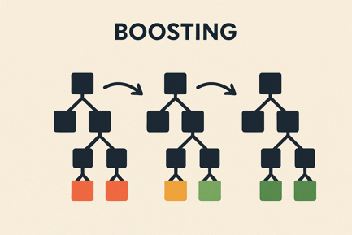

Gradient Descent
High level: We're trying to find the bottom of a hill. We take small steps in the direction that goes downhill until we can't go lower.
More precise: Gradient descent is an optimization algorithm. We compute the gradient of the loss function with respect to model parameters, and update parameters in the direction that reduces loss. XGBoost uses second-order gradients for more efficient optimization.
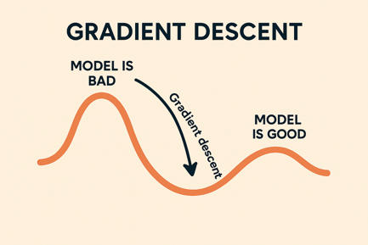

Loss Function
High level: A way of measuring how wrong our predictions are. Lower is better.
More precise: The loss function quantifies the difference between predicted and actual values. For regression tasks like ours, a common choice is mean squared error (MSE). The model is trained to minimize this.
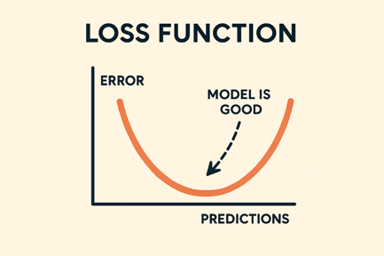

Overfitting
High level: The model has studied the training data too carefully. It's memorized the noise instead of learning the pattern. It performs great on data it has seen, but falls apart on new data.
More precise: Overfitting occurs when a model has too much flexibility and fits the training data too closely, capturing noise and random variation rather than the underlying signal. The result is low training error but high test error. In XGBoost, this can happen with too many trees, too high tree depth, or too low regularization. That's exactly why we have a test set, and why regularization matters.

Regularization
High level: We add a penalty for making the model too complicated. This helps it generalize instead of just memorizing the training data.
More precise: Regularization adds a term to the loss function that penalizes model complexity, for example the size of the weights or the number of leaves in the trees. XGBoost has built-in L1 and L2 regularization. This reduces overfitting.

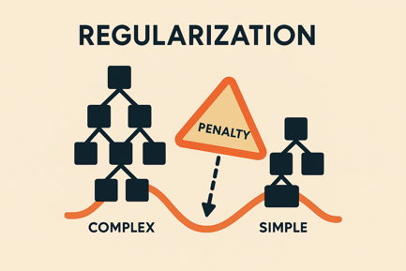

Concepts We'll Work With During the Lab

Feature Engineering – Creating or transforming input variables to help the model learn better patterns. Often where the real value is created.

Fine Tuning / Hyperparameter Tuning – Adjusting the settings of the model (tree depth, learning rate, etc.) to improve performance.
Evaluation – How do we know if the model is actually good? We'll look at metrics like RMSE, and think about what "good" even means in context.

